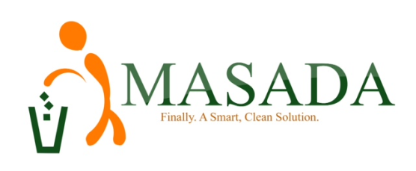
HOUSEHOLD BIN PRICE LIST
S/N | CAPACITY | MONTHLY SERVICE CHARGE (Le)
 | 240 Litre Bin | Once a Week Pickup | 150,000
 |  | Two (2) Times a Week Pickup | 300,000
 |  | Three (3) Times a Week Pickup | 450,000
 |  | Daily Pickup(Mon-Sat) | 900,000
 |  | QUARTERLY SERVICE CHARGE (LE)
 |  | Once a Week Pickup | 450,000
 |  | Two (2) Times a Week Pickup | 900,000
 |  | Three (3) Times a Week Pickup | 1,350,000
 |  | Daily Pickup(Mon-Sat) | 2,700,000
 |  | HALF YEARLY SERVICE CHARGE (LE)
 |  | Once a Week Pickup | 900,000
 |  | Two (2) Times a Week Pickup | 1,800,000
 |  | Three (3) Times a Week Pickup | 2,700,000
 |  | Daily Pickup | 5,400,000
 |  | ANNUAL SERVICE CHARGE (LE)
 |  | Once a Week Pickup | 1,800,000
 |  | Two (2) Times a Week Pickup | 3,600,000
 |  | Three (3) Times a Week Pickup | 5,400,000
 |  | Daily Pickup | 10,800,000

CALL US ON +232 99101281 OR EMAIL US Customerservice@masadasl.com or info@masadasl.com

