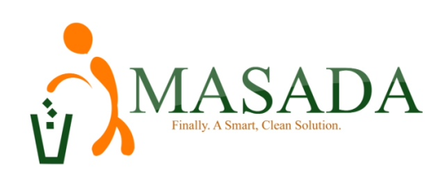
INDUSTRIAL BIN PRICE LIST
S/N | CAPACITY | MONTHLY SERVICE CHARGE (Le)
 | 1,100Litre Bin | Once a Week Pickup | 780,000
 |  | Two (2) Times a Week Pickup | 1,560,000
 |  | Three (3) Times a Week Pickup | 2,340,000
 |  | Daily Pickup(Mon-Sat) | 4,680,000
 |  | QUARTERLY SERVICE CHARGE (LE)
 |  | Once a Week Pickup | 2,340,000
 |  | Two (2) Times a Week Pickup | 4,680,000
 |  | Three (3) Times a Week Pickup | 7,020,000
 |  | Daily Pickup(Mon- Sat) | 14,040,000
 |  | HALF YEARLY SERVICE CHARGE (LE)
 |  | Once a Week Pickup | 4,680,000
 |  | Two (2) Times a Week Pickup | 9,360,000
 |  | Three (3) Times a Week Pickup | 14,040,000
 |  | Daily Pickup | 28,080,000
 |  | ANNUAL SERVICE CHARGE (LE)
 |  | Once a Week Pickup | 9,360,000
 |  | Two (2) Times a Week Pickup | 18,720,000
 |  | Three (3) Times a Week Pickup | 28,080,000
 |  | Daily Pickup(Mon-Sat) | 56,160,000

CALL US ON +232 99101281 OR EMAIL US Customerservice@masadasl.com; or info@masadasl.com

